REPOT FOR COMPANY TABLE

the query SELECT \* FROM company simply retrieves all the data stored in the "company" table. This means it will return every row and column within that table.

Here's a breakdown of what the query does:

* SELECT \*: This part of the query selects all columns from the table.
* FROM company: This specifies the table from which to retrieve the data, in this case, the "company" table.

When you execute this query, you'll get a result set containing all the records stored in the "company" table, including information such as company IDs, names, addresses, phone numbers, emails, websites, industry IDs, and country IDs.

This SQL query retrieves all data from the company table, displaying all columns and rows. Here's a breakdown of the query and its purpose:

sql

SELECT \* FROM company;

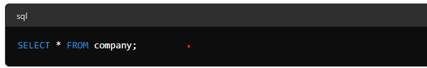Explanation:

* SELECT \*: This part of the query selects all columns from the specified table.
* FROM company: This specifies the table from which the data will be retrieved, in this case, the company table.

When you run this query, it returns all the data stored in the company table, including company IDs, names, addresses, contact details, industry IDs, and country IDs. This query helps you view all the information stored in the company table at once.